Sample VLSM Exercise
Given the Class C network of 204.15.5.0/24, subnet the network in order to create the network in the figure below, with the host requirements shown.
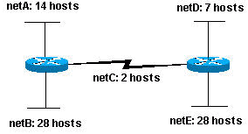

Looking at the network shown, you can see that you are required to create five subnets. The largest subnet must support 28 host addresses. Is this possible with a Class C network? and if so, then how?
You can start by looking at the subnet requirement. In order to create the five needed subnets you would need to use three bits from the Class C host bits. Two bits would only allow you four subnets (2²).
Since you need three subnet bits, that leaves you with five bits for the host portion of the address. How many hosts will this support? 2⁵ = 32 (30 usable). This meets the requirement.
Therefore you have determined that it is possible to create this network with a Class C network. An example of how you might assign the subnetworks is:
netA: 204.15.5.0/27 host address range 1 to 30
netB: 204.15.5.32/27 host address range 33 to 62
netC: 204.15.5.64/27 host address range 65 to 94
netD: 204.15.5.96/27 host address range 97 to 126
netE: 204.15.5.128/27 host address range 129 to 158

VLSM Example
In all of the previous examples of subnetting you will notice that the same subnet mask was applied for all the subnets. This means that each subnet has the same number of available host addresses. You may need this in some cases, but, in most cases, having the same subnet mask for all subnets ends up wasting address space. For example, in the solution above, a class C network was split into eight equal-size subnets; however, each subnet did not utilize all available host addresses, which results in wasted address space. The figure below illustrates this wasted address space.
Figure 4
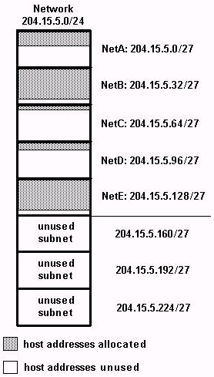
This illustrates that of the subnets that are being used, NetA, NetC, and NetD have a lot of unused host address space. This may have been a deliberate design accounting for future growth, but in many cases this is just wasted address space due to the fact that the same subnet mask is being used for all the subnets.
Variable Length Subnet Masks (VLSM) allows you to use different masks for each subnet, thereby using address space efficiently.

VLSM Example
Given the same network and requirements as the example above, develop a subnetting scheme using VLSM, given:
netA: must support 14 hosts
netB: must support 28 hosts
netC: must support 2 hosts
netD: must support 7 hosts
netE: must support 28 host
Determine what mask allows the required number of hosts.
netA: requires a /28 (255.255.255.240) mask to support 14 hosts
netB: requires a /27 (255.255.255.224) mask to support 28 hosts
netC: requires a /30 (255.255.255.252) mask to support 2 hosts
netD*: requires a /28 (255.255.255.240) mask to support 7 hosts
netE: requires a /27 (255.255.255.224) mask to support 28 hosts

* a /29 (255.255.255.248) would only allow 6 usable host addresses
therefore netD requires a /28 mask.
The easiest way to assign the subnets is to assign the largest first. For example, you can assign in this manner:
netB: 204.15.5.0/27 host address range 1 to 30
netE: 204.15.5.32/27 host address range 33 to 62
netA: 204.15.5.64/28 host address range 65 to 78
netD: 204.15.5.80/28 host address range 81 to 94
netC: 204.15.5.96/30 host address range 97 to 98
This can be graphically represented as shown in the figure below:
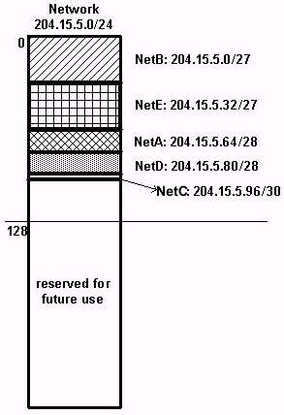
This illustrates how using VLSM helped save more than half of the address space.

